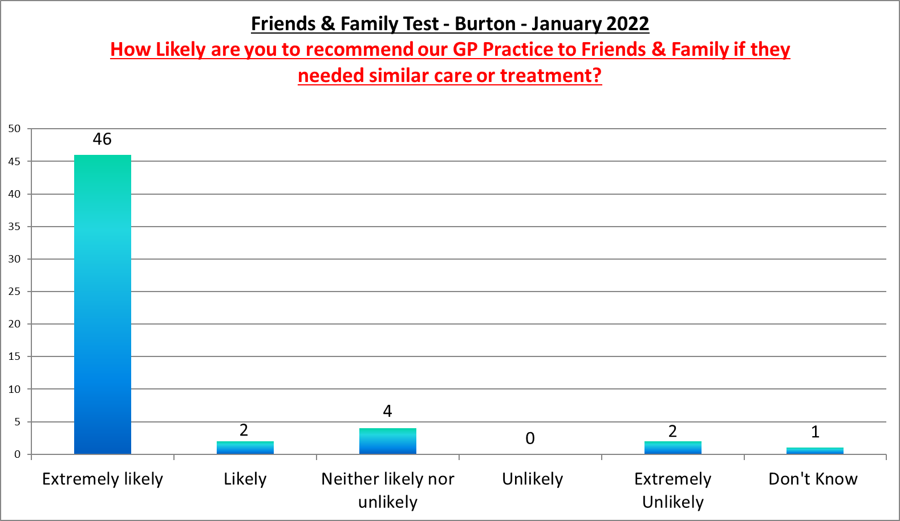

Burton Surgery

**Positive Comments**

Very good treatment with Dr Samuels

Very professional and friendly

Although my recent appointment was very professional my previous appointment at Winterton wasn't so good as the receptionist at Burton

**Negative Comments**